ER DIAGRAM OF SYSTEM

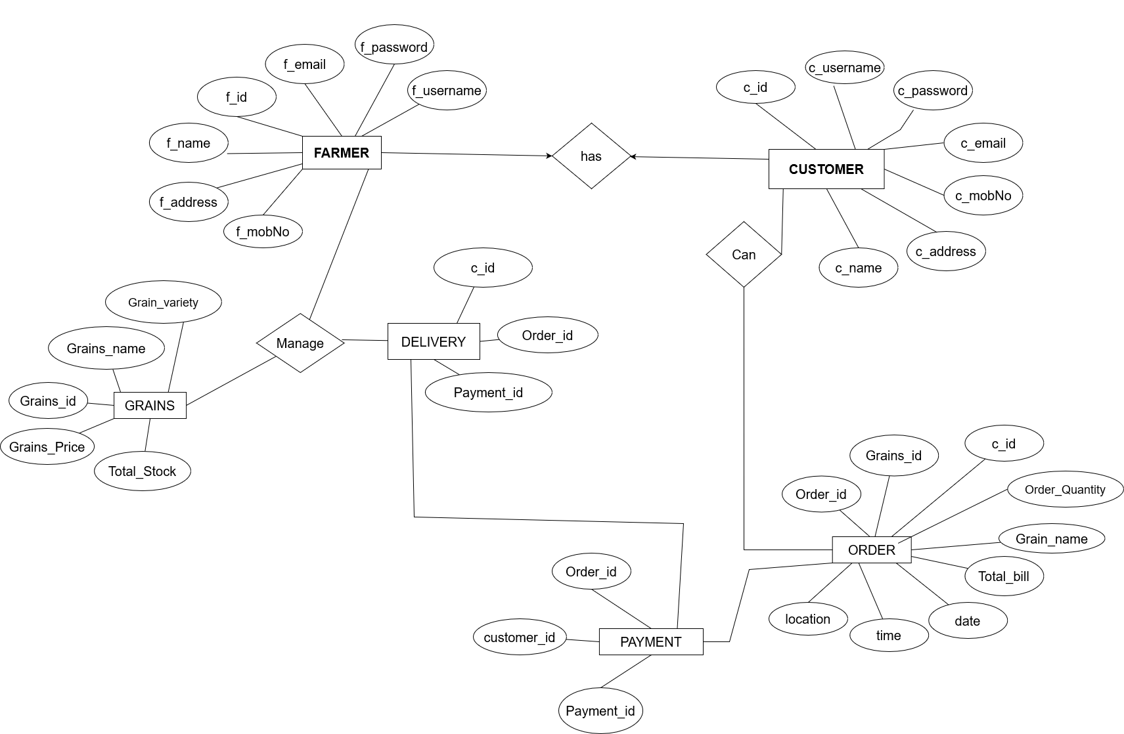

SEQUENCE DIAGRAM OF ORDER

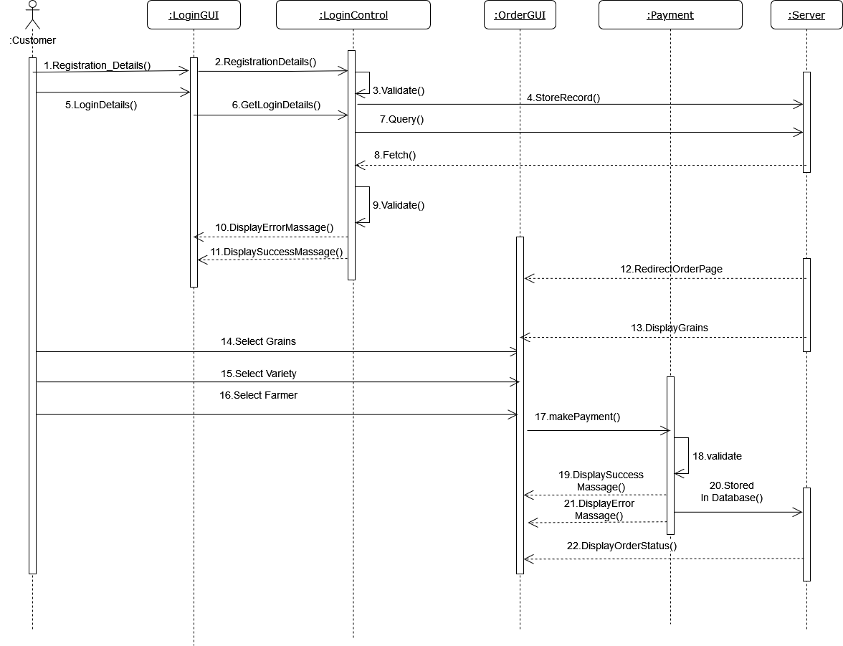

SEQUENCE DIAGRAM FOR PAYMENT AND DELIVERY

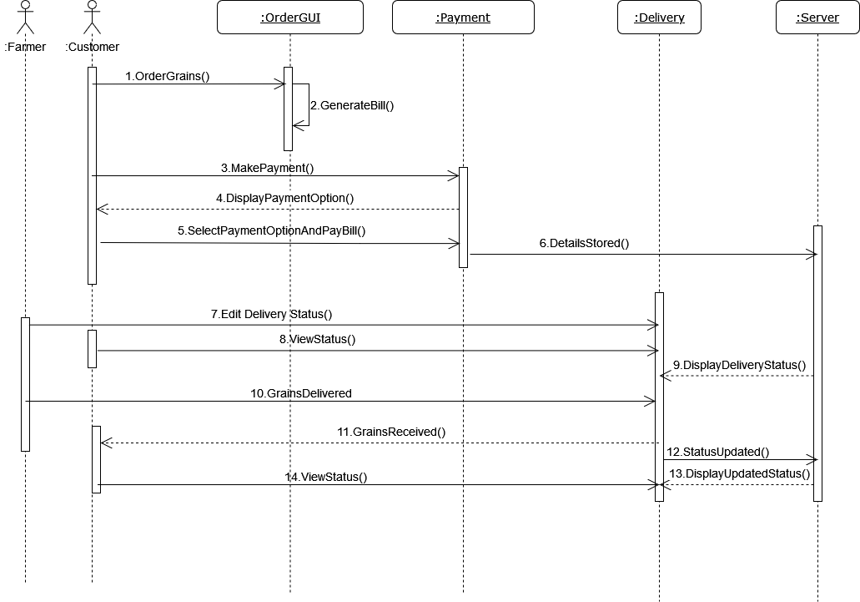

SEQUENCE DIAGRAM FOR GRAINS

